CS506 – Programming for Computing
HOS01 Introduction to Python Part 1
12/02/2025 Reviewed by Rajdeep Singh Golan
2/6/2026 Revised by Jonathan Koerber
09/08/2026 Reviewed by Giridhar Dronamraju

School of Technology & Computing (STC)
City University of Seattle (City U)

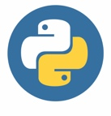
Before You Start
- Screenshots may be different from your environment.
- The directory path shown in screenshots may be different from yours.
- There might be subtle discrepancies along with the steps. Please use your best judgment while going through this cookbook-style tutorial to complete each step.
- Some steps may not be explained in detail. If you are not sure what to do:
- Consult the resources from the course.
- If you cannot solve the problem after a few tries (usually 15 -30 minutes), ask a TA for help.

Resources
- Python crash course: a hands-on, project-based introduction to programming: Matthes, E. (2019): Available online link

Learning Outcomes
- Section 1: Preparing your environment
- Section 2: Variables, Data Types, and User Input
- Section 3: Multiple assignments
- Section 4: String functions and Concatenation
- Section 5: Numbers and operators
- Section 6: Using Python for Decision Making
- Section 7: Using Loops in Lists
- Section 8: Dictionary Data Type
- Section 9: Looping in Dictionary

Section 1: Preparing your environment
Get started with your virtual environment here:
https://cityuseattle.github.io/docs/git/getting-started-codespace/
  - In Codespaces, open the private repository generated when you accept the HOS01 assignment. Create a folder named Module 1 and you will be working in this folder now.
(You can also do it locally on your machine, but Codespaces is recommended. For a local setup, you need to clone and work on it. If you cannot find that repository on your machine, you might not have cloned the repo; if so, please do so before proceeding).

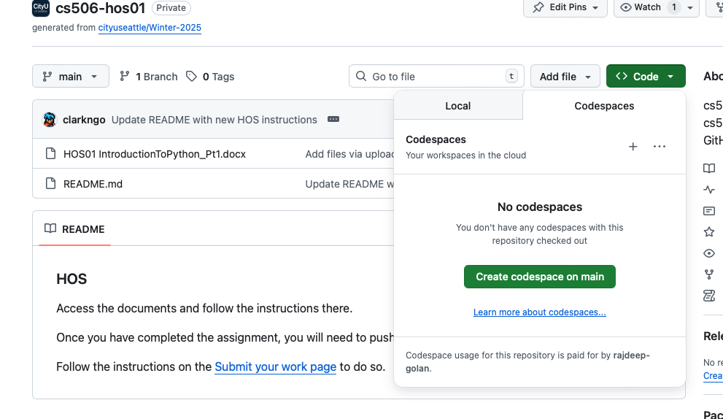
GitHub Codespaces User Interface:
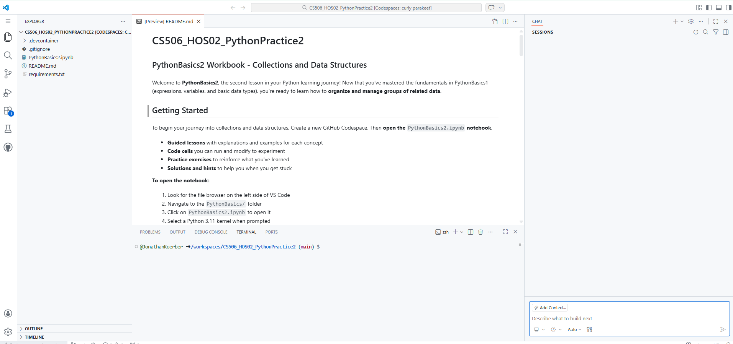
Terminal
Copilot Chat
Incorporating AI into your Learning Workflow
In this course, we embrace the future of development. Tools like GitHub Copilot, Gemini, and ChatGPT are integrated into modern environments like GitHub Codespaces and VS Code. Our goal is to use these tools not as "answer engines," but as Socratic Tutors.
The "Socratic Tutor" Philosophy
A Socratic tutor doesn't give you the answer; they ask the right questions to help you find the answer yourself. When using AI, your goal is to understand the logic, not just the output.
Guide for best results:
- Explain, Don't Replace: Use AI to explain error messages or logic. Never copy-paste code without being able to explain what every line does.
- The 10-Minute Rule: If you are stuck on a "creative judgment" problem for more than 10 minutes, describe your problem to the AI and ask for a "hint" rather than the full solution.
- Verify the Output: AI can sometimes "hallucinate" (make mistakes). Always compare the AI’s explanation with the actual results you see.
- Cite Your Assistant: If an AI helps you solve a particularly difficult bug, add a comment in your code like: # Logic assisted by AI to resolve non-numeric error

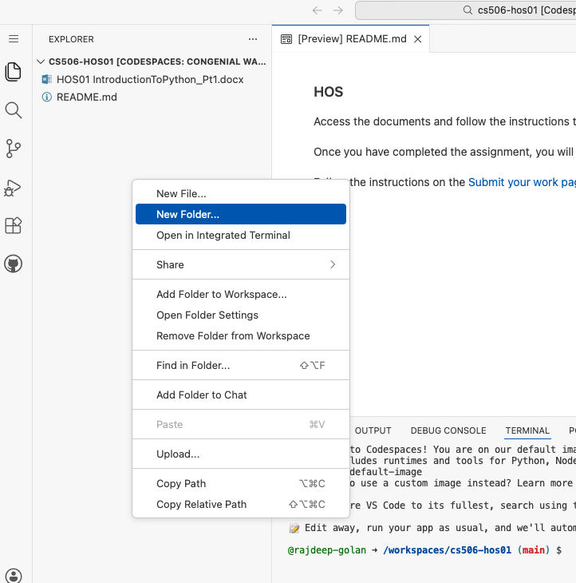

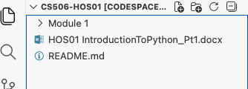
  - Open the terminal by hitting the control + ~ keys, OR by clicking on the bottom bar icon on the right corner of the screen.
Then navigate into the Module 01 folder using the following command: cd Module\ 1
Note we Use a backslash ( \ ) before the space to escape its special meaning.

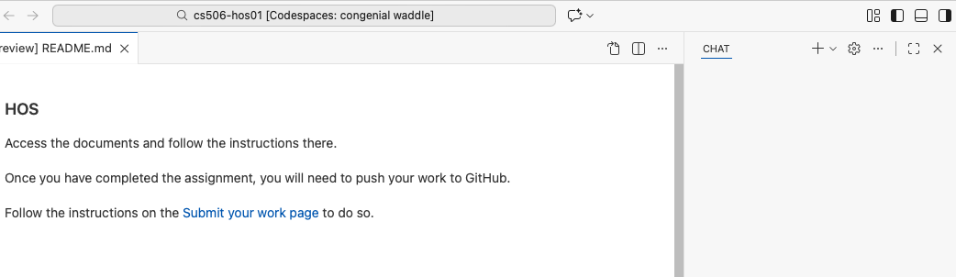

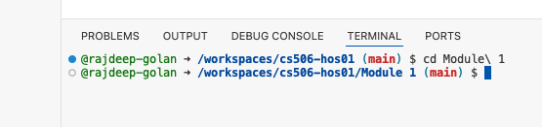

Section 2: Variables, Data Types, and User Input
Follow the video instructions below to code along: https://youtu.be/5Y9AENc6o2Y
- Variables: Variables are containers for storing data values. Unlike other programming languages, Python has no command for declaring a variable. A variable is created the moment you first assign a value to it.
More about variables: https://www.w3schools.com/python/python_variables.asp
- Data Types: Data types are the classification or categorization of data items. Data types represent a kind of value that determines what operations can be performed on that data. Numeric, non-numeric, and Boolean (true/false) data are the most used data types.
More about data types: https://www.w3schools.com/python/python_datatypes.asp
- User Input: To receive information through the keyboard, Python uses the input() function.
When the input() function is called, the program flow stops until the user enters the input via the command line. To enter the data, the user needs to press the ENTER key after inputting the string. The input() function, by default, will convert all the information it receives into a string.
More about user input: https://www.w3schools.com/python/python_user_input.asp

Section 3: Multiple assignments
Python allows you to assign values to multiple variables in one line, and you can assign the same value to multiple variables in one line. For example:
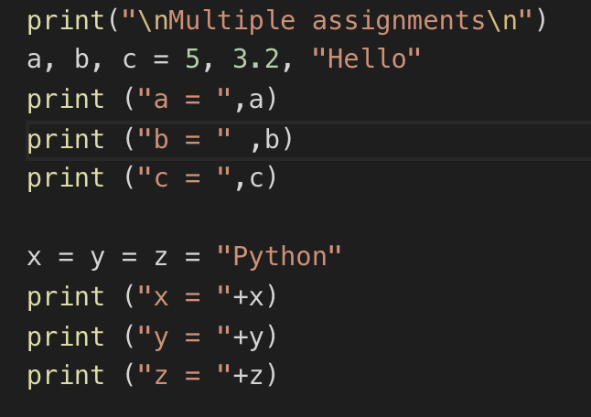
(Note: this is optional, you do not have to write the code in the above screenshot)

Section 4: String functions and Concatenation
Follow the video instructions below to code along: https://youtu.be/9zW8GEogRKc

In Python, there are a few ways to concatenate – or combine - strings. The new string that is created is referred to as a string object. This is because everything in Python is an object, which is why

Python is an object–oriented language. Another way to concatenate strings is as shown below:

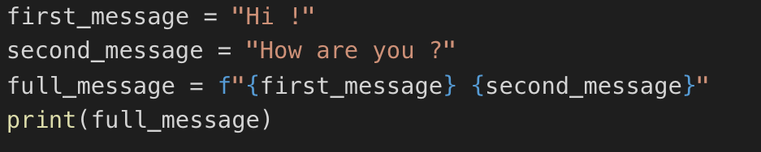
(Note: this is optional, you do not have to write the code in the above screenshot)
Output:
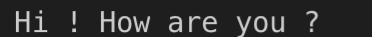

Explanation: Also called “formatted string literals,” f-strings are string literals that have an f at the beginning and curly braces containing expressions that will be replaced with their values. The expressions are evaluated at runtime and then formatted using the __format__ protocol.

Section 5: Numbers and operators
Operators are constructs that can manipulate the value of operands.
Consider expression 4 + 5 = 9. Here, 4 and 5 are called operands and + is called the operator.
Python language supports the following types of operators.
  - Arithmetic Operators
  - Comparison (Relational) Operators
  - Assignment Operators
  - Logical Operators
  - Bitwise Operators
  - Membership Operators
  - Identity Operators
The commonly used operators are underlined above. More about numbers and operators: https://www.tutorialspoint.com/python/python_basic_operators.htm

1) Under Module 1, create a file Numbers.py and type the following code.
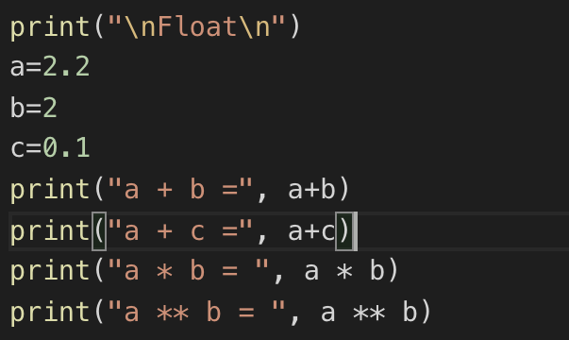
2) Type the following to get the output of the code in the terminal
python Numbers.py
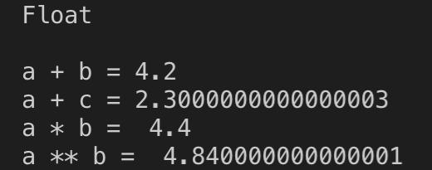

If you look at the answer of a+c and a**b, it is displayed as an arbitrary number of decimal places. This happens in all languages and is of little concern. Python tries to find a way to represent the result as precisely as possible, which is sometimes difficult given how computers must represent numbers internally.
Section 6: Python Decision Making
Decision making involves anticipating conditions that occur during program execution and specifying actions based on these conditions.
1) Create a HOS01_ELIF.py file in Module 1, follow the below video instruction to code along: https://youtu.be/4rIRG1aMEvM
Challenge: Fix the program so that the user input can be recognized as an integer. Expected result:
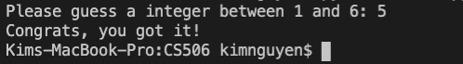
Elif: The elif keyword is Python's way of saying "if the previous conditions were not true, then try this condition". Create the IfControl.py file in the Module 1 folder and type the following code:
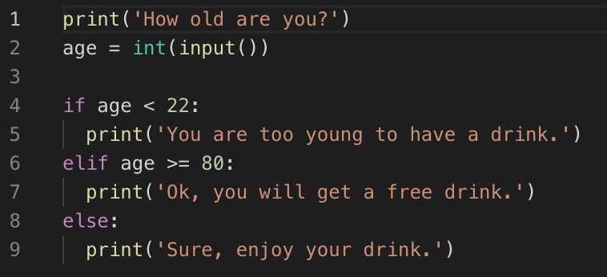

2) Use the following command and give different input to test the program:
python IfControl.py

More about if statements: https://www.w3schools.com/python/python_conditions.asp
Loops: In general, statements are executed sequentially: The first statement in a function is executed first, followed by the second, and so on. There may be a situation when you need to execute a block of code several times. Programming languages provide various control structures that allow for more complicated execution paths. A loop statement allows us to implement a statement or group of statements multiple times.

While loop: Follow the video instructions below to code along: https://youtu.be/_3665KzFlO8

Syntax:
while expression:
statement(s)
Statement(s) may be a single statement or a block of statements. The condition may be any expression, and true is any non-zero value.
In Python, all the statements indented by the same number of character spaces after a programming construct are part of a single block of code. Python uses indentation as its method of grouping statements.

How does the while loop work?
- The while loop runs as long as, or while, a certain condition is true.
- The loop iterates while the condition is true.
- When the condition becomes false, program control passes to the line immediately following the loop.

More about while loops: https://www.w3schools.com/python/python_while_loops.asp

Challenge: Modify the program to limit the number of attempts to guess 3 instead of 4.

Use AI to get more details: Your text asks you to modify a program to limit the number of attempts to 3 instead of 4. A common mistake is being "off by one" (ending up with 2 or 4 attempts instead of exactly 3).
Task: Instead of asking the AI for the code, use one of the following prompts to understand the logic:
- Prompt A: "I am using a while loop with a counter. If I want the loop to run exactly 3 times, should my condition be counter < 3 or counter <= 3 if I start counting at 0? Explain the logic."
- Prompt B: "Explain the 'off-by-one' error in Python while loops when using a counter variable."
Add your prompts to a Word Document to explain if you had to change anything.

For loop: “for” loops are traditionally used when you have a block of code that you want to repeat a fixed number of times. For statement iterates over the members of a sequence in order, executing the block each time.

Syntax:
for iterating_var in sequence:
statements(s)

If a sequence contains an expression list, it is evaluated first. Then, the first item in the sequence is assigned to the iterating variable iterating_var. Next, the statement block is executed. Each item in the list is assigned to iterating_var, and the statement(s) block is executed until the entire sequence is exhausted.

3) Create a ForControl.py file in Module 1 and type the code below:
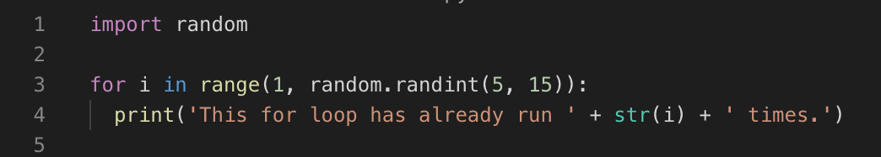

Note: We import the random function to generate a random number from 5 to 15 (exclusive) for the end range number.

In the terminal, type the following command: python ForControl.py
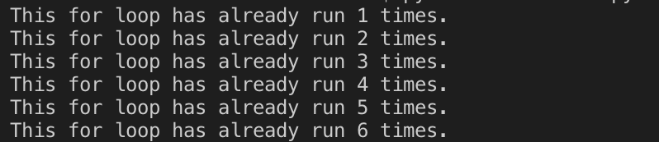

Section 7: Using Loops in lists
Let us use for loop to print out all the elements of a list. Create a file replaceNegative.py under Module 1 and enter the following code:

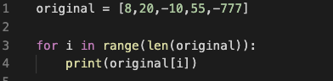

The range () function causes Python to start counting at 0, and it stops when it reaches the length of the list. The len () function calculates the length of the list. The i consists of the range index, and it is used for navigating throughout the list. If the value in the list is less than 0, it is converted to an absolute value and returned to the list.

In the terminal, type the following command: python replaceNegative.py

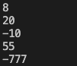

Challenge: Edit the program to replace any negative numbers in the list with positive ones. Expected result:

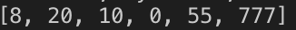

Hint: You can use the abs () function to turn negative numbers into positive numbers

Challenge: Nondestructive Absolut Value.
Redefine your list, so you have and write a loop that prints the absolute value of the number but doesn’t change the value in the list. In

Task: Ask the AI for a "hint" on the math function needed here.
- Prompt: "How can I access the elements of the list to convert to absolute value but not change the underlying data?”
Explain why it was necessary to change the code to do this and add the prompts that you asked for AI.

Section 8: Dictionary Data Type
A dictionary is a collection of many values. Unlike lists, indexes for dictionaries can use many different data types, called keys, and a key with its associated value is called a key-value pair. Each key is separated from its value by a colon (:), commas separate the items, and the whole thing is enclosed in curly braces. Keys are unique within a dictionary, while values may not be. The values of a dictionary can be of any type, but the keys must be of an immutable data type such as strings, numbers, or tuples.

In the Dictionary, functions like accessing values, updating the dictionary, adding new pairs, and deleting elements can be performed.

- Under Module 1, create a file dictionary.py and type the code below. This program describes how to access, update, add, and delete items in a dictionary.

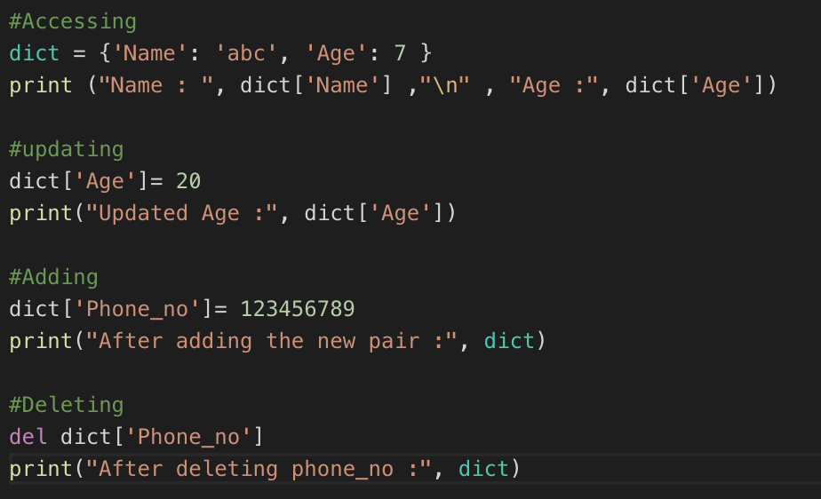

- In the terminal, type the following to check the output for the above code: python dictionary.py

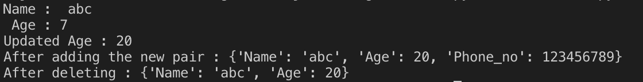

Note: If the key you ask for does not exist, you will get an error. More than one entry per key is not allowed. Which means no duplicate key is permitted. When duplicate keys are encountered during assignment, the last assignment wins.

A dictionary is unordered. Thus, if you compare two dictionaries with duplicate content but not the same order, it will return true.

- Let us find out what will happen when we compare two lists and a dictionary with similar values but different orders. Under Module 1, create a file, compare.py and type the code below.

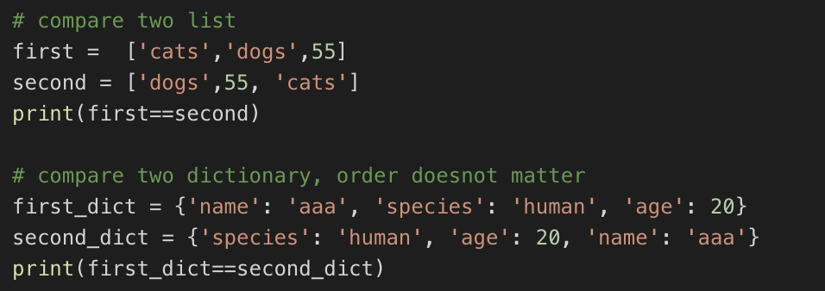

- Type the following in the terminal to check the output of the above code:
python compare.py

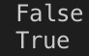

The output on the terminal should be False and True, respectively, because order matters in a List but not in a Dictionary if it contains the same values.

Section 9. Looping in Dictionary
A single Python dictionary can contain just a few key-value pairs or millions of pairs. Python lets you loop through a dictionary. You can loop through all dictionary key-value pairs, through their keys, or through their values.

- Under Module 1 create a file dict_for.py and type the code below. This program explains how multiple dictionaries are combined and used inside a loop for accessing the key and value.
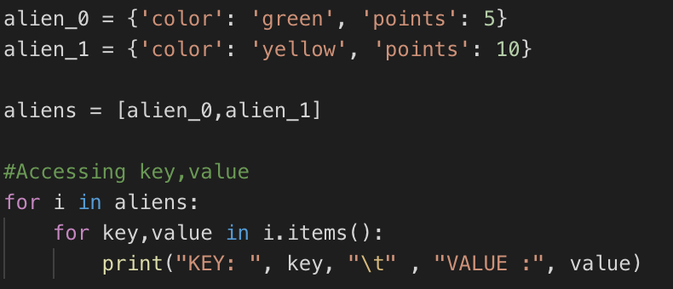
Type python dict_for.py in the terminal to check the output.

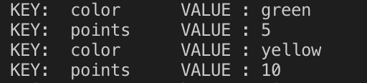

Note: For accessing only keys, use .keys() and for values use .values() in the loop.

2) Let us create a program to find the richest man from the dictionary and save it as richest.py

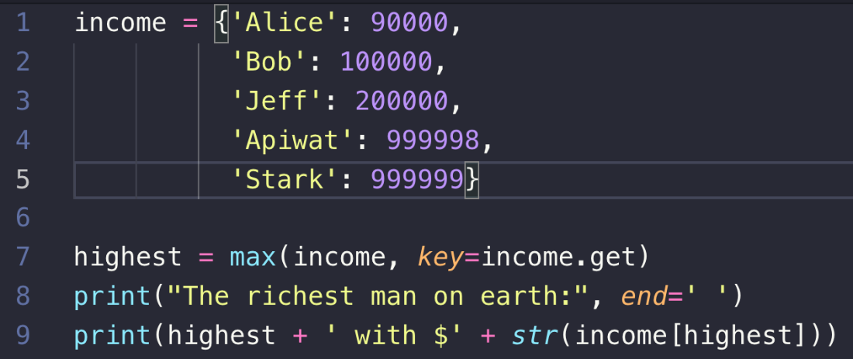

Type “python richest.py” in the terminal. The result would show Stark is the richest man on Earth.

Challenge: Modify the code above to display the person with the lowest income.

Push your work to GitHub Codespaces
Follow instructions here: https://cityuseattle.github.io/docs/git/github_upload_files/

